Extra Credit

Name: _______________

Log on to Oracle SQL Developer using the user account HR password HR. Query the sample HR database schema and answer the following questions.

- Create a report that shows the name, location, and number of employees for each department. Make sure that the report also includes departments without employees.
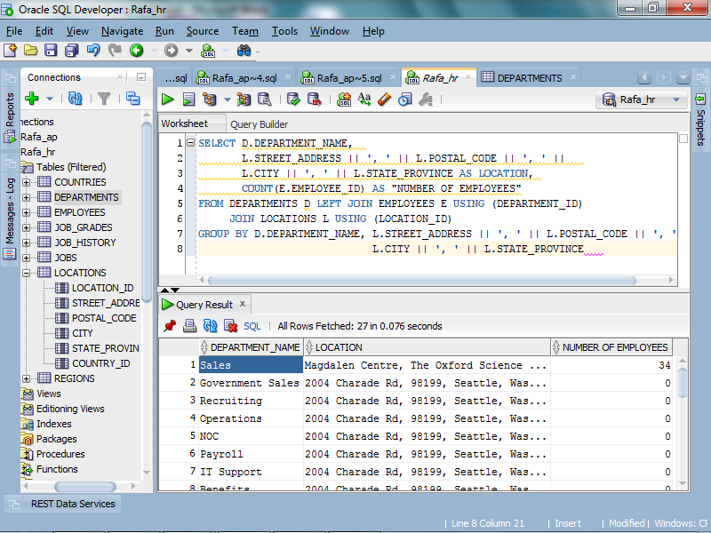

- Create a report that displays the jobs that are found in the Administration and Executive departments. Also display the number of employees for these jobs. Show the job with the highest number of employees first.
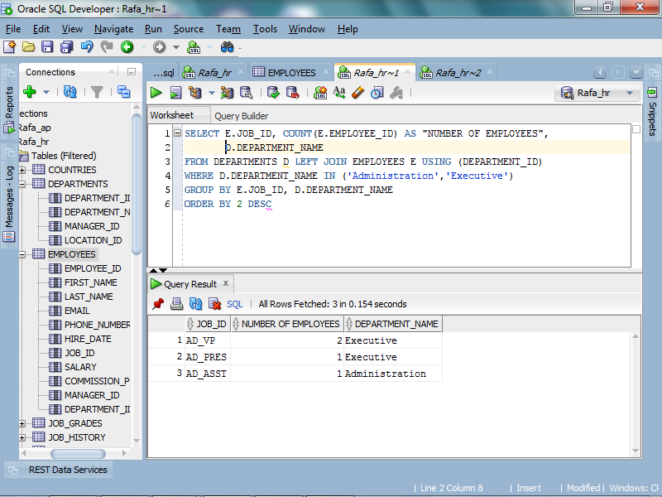

- Create the following reports for the HR department: Include the department number, department name, and the number of employees working in each department that:

- Employs fewer than three employees
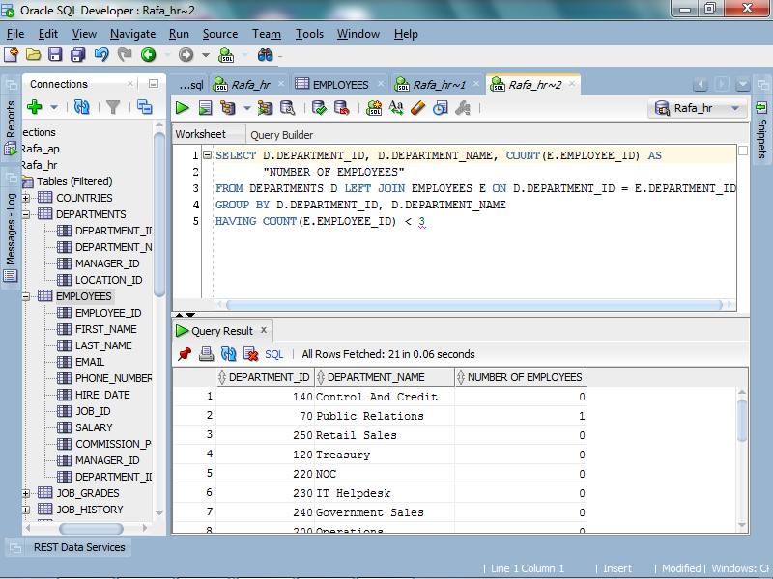

- Has the highest number of employees
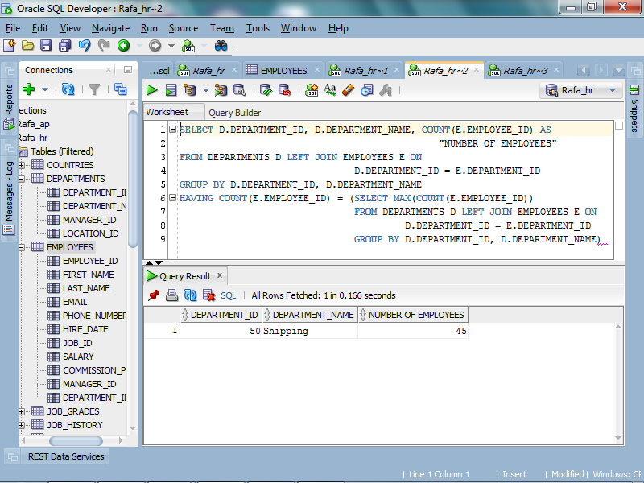

- Has the lowest number of employees
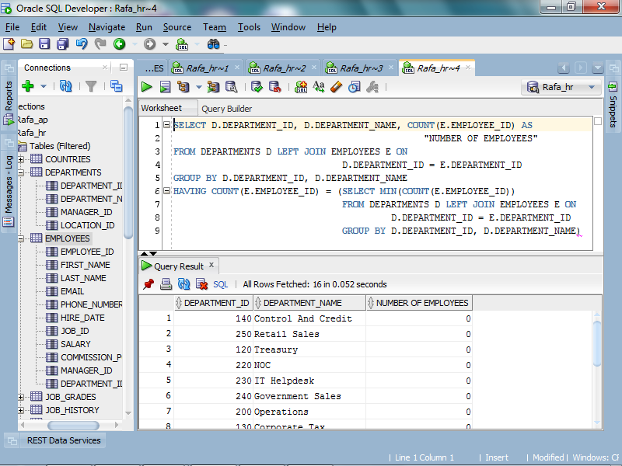

- Create a report that displays departments where no sales representatives work. Include the department number, department name, and location in the output.
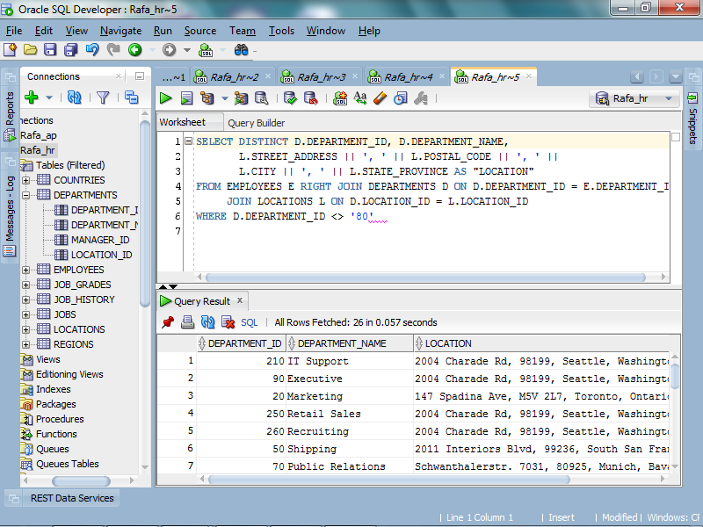

- Create a report for HR that displays the department number, last name, and job ID for every employee in the Executive department.
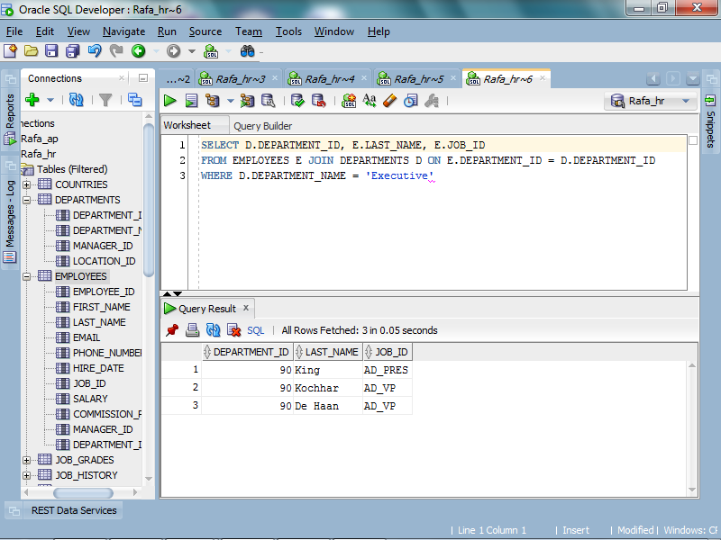
- Calculate the number of days from today to Christmas. Use TO_CHAR to format the output.
